 [Translated from German to English - www.onlinedoctranslator.com](https://www.onlinedoctranslator.com/en/?utm_source=onlinedoctranslator&utm_medium=docx&utm_campaign=attribution)

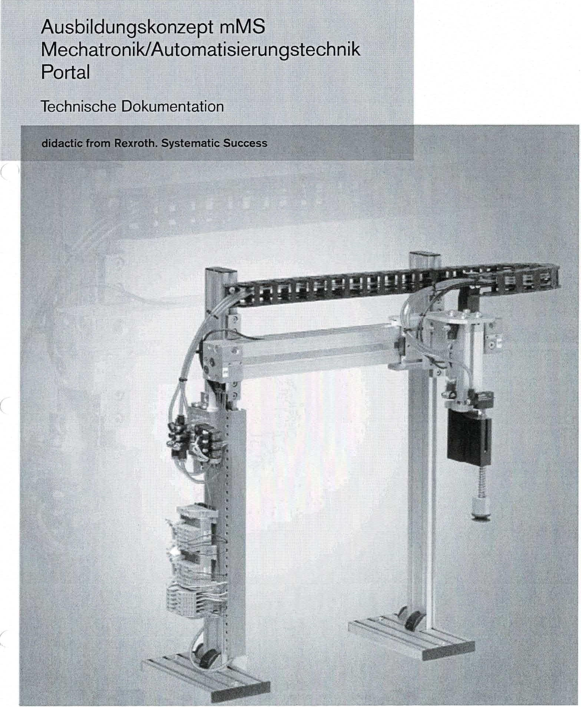

didactic from Rexroth. S

mMS training concept

Mechatronics/Automation Technology

portal

Technical documentation

|  |  |  |  |
| --- | --- | --- | --- |
| IIndustrial Hydraulics | Electric Drives ILinear Motion and  and Controls E Assembly Technologies Pneumatics | Mobile Service  Automation Hydraulics | **Rexroth**  **Bosch Group** |

i

© by Dr.-Ing. Paul Christiani GmbH & Co. KG **3**

|  |  |  |
| --- | --- | --- |
| portal |  | Technical documentation |
| **Table of contents**  **1 Mechanics** | |  |
| 1.1 | Functional description | 5 |
| 1.2 | Overall drawings | 7 |
| 1.3 | Complete parts list | 11 |
| **2** | **E-pneumatics** |  |
| 2.1 | Pneumatic plan | 15 |
| **3** | **Electrics** |  |
| 3.1 | Circuit diagram / terminal diagrams | 17 |
| **4** | **PLC program** |  |
| 4.1 | Program description | 27 |
| 4.2 | Technology scheme | 29 |
| 4.3 | Function plan | 31 |
| 4.4 | Program steps | 33 |
| **5** | **Commissioning instructions** | 37 |

**1 Mechanics**

Technical Documentation Portal

© by Dr.-Ing. Paul Christiani GmbH & Co. KG 5

**1.1 Functional description**

The portal functional assembly has the task of removing machined workpieces from the press and transporting them to the next station.

The portal essentially consists of the frame construction of rodless cylinders/profiles 40x20 and the suction cup assembly.­

The workpieces are picked up by the suction unit. The suction cup extends downwards. After picking up, the suction cup returns to the upper position, and the shuttle cylinder carries out the actual workpiece transport in a horizontal direction. At the end of the stroke, the workpiece is deposited again by the extending suction unit.

The portal is mounted on 2 base plates and can be mounted together with other functional assemblies on an aluminum profile plate.

Two 8-bit transfer connectors are available as transfer modules for connection to four digital PLC inputs and three digital PLC outputs.

The supply voltage of the functional module is 24 VDC and is established via the 10-pin connecting cable

The air supply is via a 4 mm air connection, the operating pressure is 4 bar.

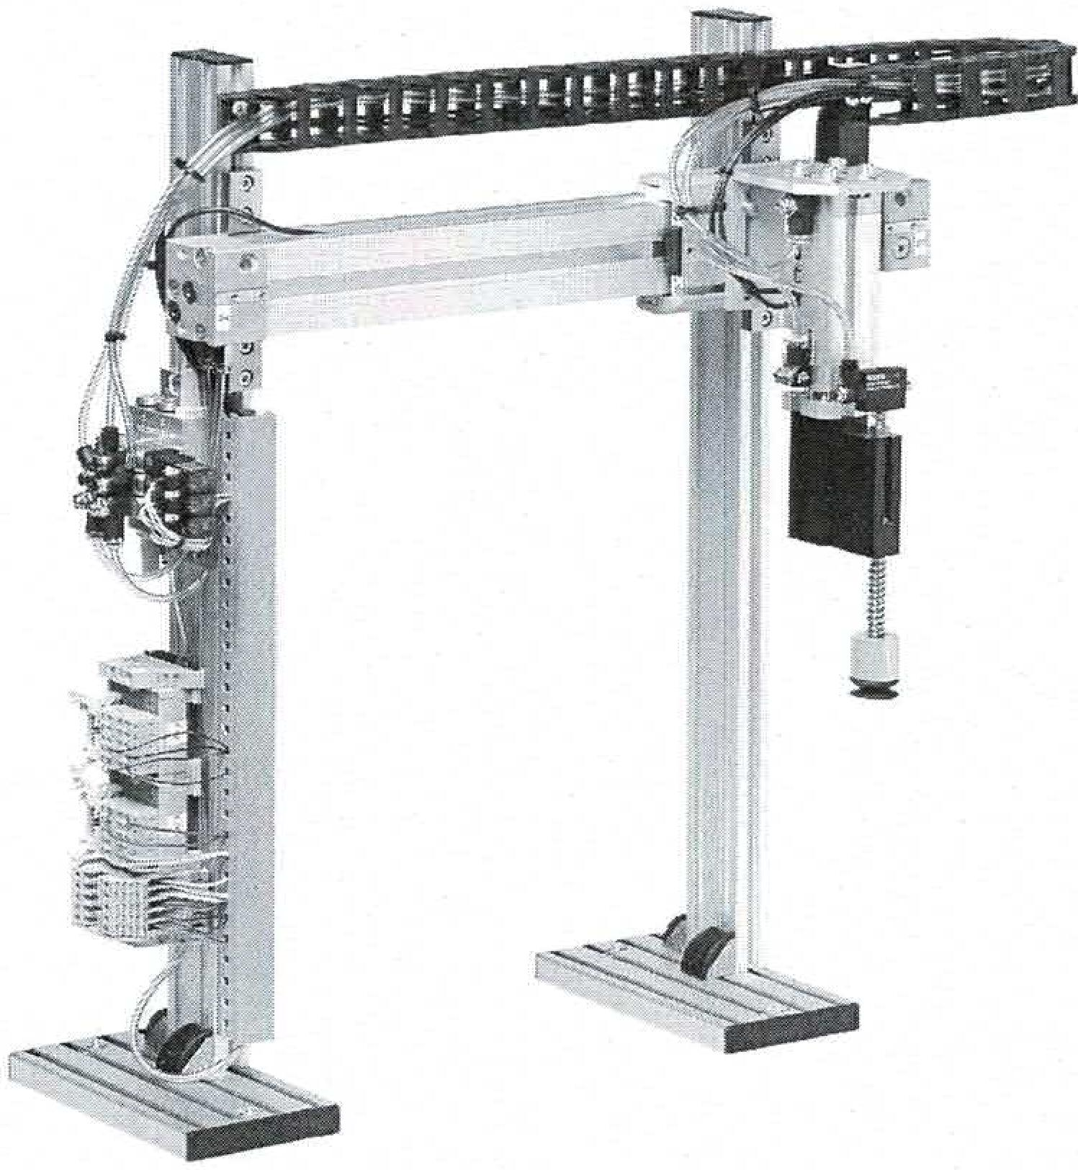

0 by ❑r.-Ing. Paul Christiani GmbH & Co. KG

|  |  |  |  |
| --- | --- | --- | --- |
| Item No. | designation | Christiani No. | Crowd |
| 1 | Cylinder kit without piston rod | 33100134 | 1 |
| 2 | Kit feet Al profile 40x20x480 | 33100135 | 2 |
| 3 | Kit base plate 80114x145 | 33100142 | 2 |
| 4 | Suction cup kit with attachment | 33100137 | 1 |
| 5 | Electrical connection | 33100009 | 1 |
| 6 | Valve island for 3 connections | 33100074 | 1 |
| 7 | Pneumatic directional valve | 33100162 | 1 |
|  | Mounting kit for shuttle cylinder | 33100138 | 4 |
| 9 | Pneumatic directional valve | 33100160 | 1 |
| 10 | Energy chain kit | 33100158 | 1 |
| 11 | Pneumatic 5/2 way valve with accessories | 33100161 | 1 |
| 12 | Electrical kit wiring duct 20x20x3C, 03100159 | | 1 |

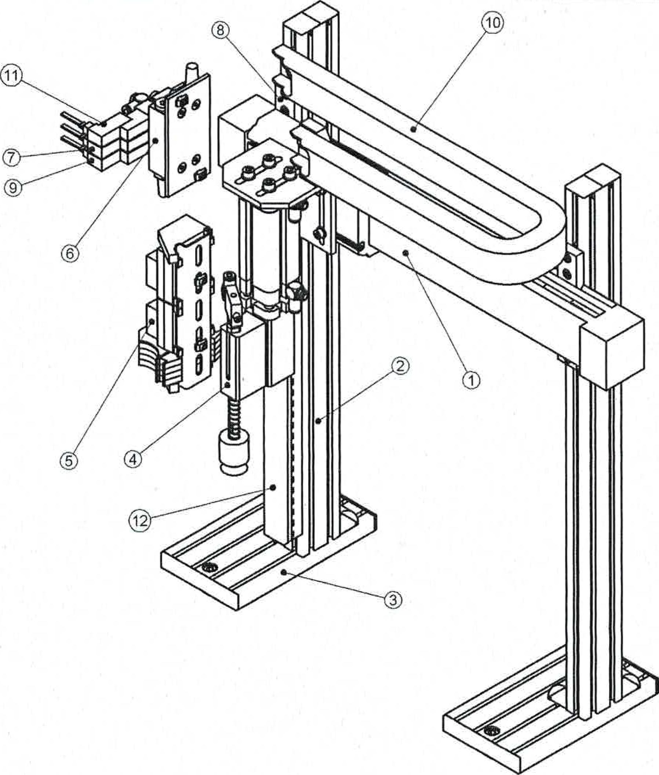

Overall drawing portal

Drawing 33100136 06-10-2003Leaves: 2

Christiani

Technical information for Ass- and Weilerbiirhing

teCopyright Dr.-Ing. Paul Chrisliemi GmbH & Co. KG

**uaßunuyopziweseo**

uop4mawmp❑ apspqoal

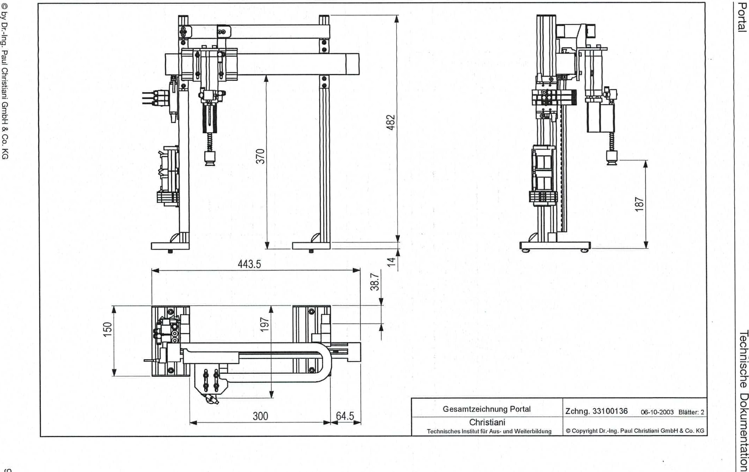

by Dr.-Ing. Paul Christiani GmbH & Co. KG

uo!leluawmp❑ agospLioal

CO

Drawing 33100136 06-10-2003 Pages: 2

0 Copyright Dr.-Ing. Paul Christiani GmbH & Co. KG

Christiani

Technical Institute for Education and Training

Overall drawing portal

O

ti

CO

CO

443.5

rrn

■